Applications of op amp:
Inverting Amplifier as summing, averaging and scaling amplifier:
The configuration is shown in fig. 2. With three input voltages v_{a}, v_{b} & v_{c}. Depending upon the value of R_{f} and the input resistors R_{a}, R_{b}, R_{c} the circuit can be used as a summing amplifier, scaling amplifier, or averaging amplifier.
Again, for an ideal OPAMP, v₁ = v₂. The current drawn by OPAMP is zero. Thus, applying KCL at v₂ node  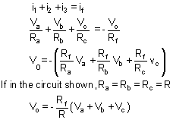  This means that the output voltage is equal to the negative sum of all the inputs times the gain of the circuit R_{f}/ R; hence the circuit is called a summing amplifier. When R_{f}= R then the output voltage is equal to the negative sum of all inputs.  v_{o}= -(v_{a}+ v_{b}+ v_{c}) | 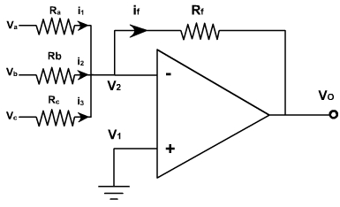  Fig. 2
If each input voltage is amplified by a different factor in other words
weighted differently at the output, the circuit is called then scaling amplifier.

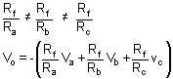
The circuit can be used as an averaging circuit, in which the output voltage is equal to the average of all the input voltages.
In this case, R_{a}= R_{b}= R_{c} = R and R_{f} / R = 1 / n where n is the number of inputs. Here R_{f} / R = 1 / 3.
v_{o} = -(v_{a}+ v_{b} + v_{c}) / 3
In all these applications input could be either ac or dc.
Integrator:
A circuit in which the output voltage waveform is the integral of the input voltage waveform is called integrator. Fig. 4, shows an integrator circuit using OPAMP.
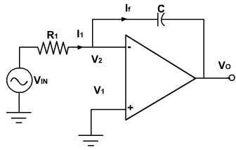
Fig. 4
Here, the feedback element is a capacitor. The current drawn by OPAMP is zero and also the V₂ is virtually grounded.
Therefore, i₁ = i_{f} and v₂ = v₁ = 0
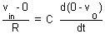
Integrating both sides with respect to time from 0 to t, we get
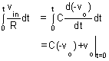
$$v_{o=1/RC}\int_{0}^{t}{v_{in}dt}$$
The output voltage is directly proportional to the negative integral of the input voltage and inversely proportional to the time constant RC.
If the input is a sine wave the output will be cosine wave. If the input is a square wave, the output will be a triangular wave. For accurate integration, the time period of the input signal T must be longer than or equal to RC.
Fig. 5, shows the output of integrator for square and sinusoidal inputs.
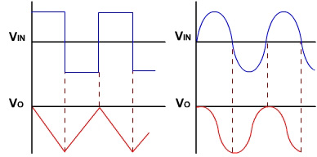
Fig. 5
Differentator:
A circuit in which the output voltage waveform is the differentiation of input voltage is called differentiator .as shown in fig. 1.
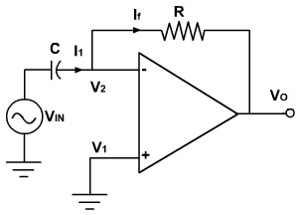 | 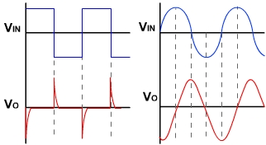
Fig. 1
The expression for the output voltage can be obtained from the Kirchhoff’s current equation written at node v₂.
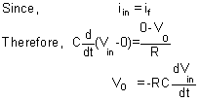
Thus the output v_{o} is equal to the RC times the negative instantaneous rate of change of the input voltage v_{in} with time. A cosine wave input produces sine output. fig. 1 also shows the output waveform for different input voltages.  The input signal will be differentiated properly if the time period T of the input signal is larger than or equal to R_{f} C.  T≥ R_{f} C  As the frequency changes, the gain changes. Also at higher frequencies the circuit is highly susceptible at high frequency noise and noise gets amplified. Both the high frequency noise and problem can be corrected by additing, few components. as shown in fig. 2. | 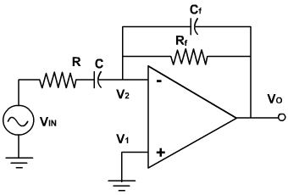  Fig. 2

Comparators:
An analog comparator has two inputs one is usually a constant reference voltage V_{R} and other is a time varying signal v_{i} and one output v_{O}. The basic circuit of a comparator is shown in fig. 5.
When the noninverting voltage is larger than the inverting voltage the comparator produces a high output voltage (+V_{sat}). When the non-inverting output is less than the inverting input the output is low (-V_{sat}). Fig. 5, also shows the output of a comparator for a sinusoidal.
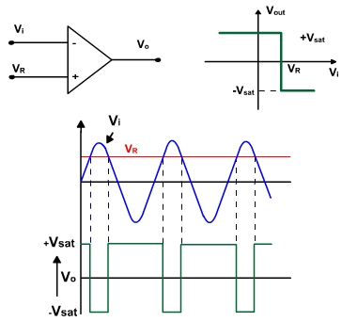
Fig. 5
v_{O} = -V_{sat} if v_{i} > V_{R}
= + V_{sat} if v i < V_{R}
If V_{R} = 0, then slightest input voltage (in mV) is enough to saturate the OPAMP and the circuit acts as zero crossing detector as shown in fig. 6. If the supply voltages are ±15V, then the output compliance is from approximate – 13V to +13V. The more the open loop gain of OPAMP, the smaller the voltage required to saturate the output. If v_{d} required is very small then the characteristic is a vertical line as shown in fig. 6.
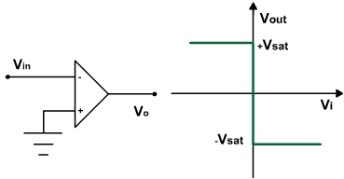
Fig. 6
Schmitt Trigger:
If the input to a comparator contains noise, the output may be erractive when v_{in} is near a trip point. For instance, with a zero crossing, the output is low when v_{in} is positive and high when v_{in} is negative. If the input contains a noise voltage with a peak of 1mV or more, then the comparator will detect the zero crossing produced by the noise. Fig. 1, shows the output of zero crossing detection if the input contains noise.
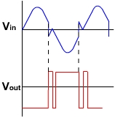 | 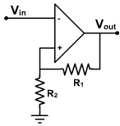
Fig. 1 | Figure 19.2
This can be avoided by using a Schmitt trigger, circuit which is basically a comparator with positive feedback. Fig. 2, shows an inverting Schmitt trigger circuit using OPAMP.
Because of the voltage divider circuit, there is a positive feedback voltage. When OPAMP is positively saturated, a positive voltage is feedback to the non-inverting input, this positive voltage holds the output in high stage. (v_{in}< v_{f}). When the output voltage is negatively saturated, a negative voltage feedback to the inverting input, holding the output in low state.
When the output is +V_{sat} then reference voltage V_{ref} is given by
If V_{in} is less than V_{ref} output will remain +V_{sat}.
When input v_{in} exceeds V_{ref} = +V_{sat} the output switches from +V_{sat} to –V_{sat}. Then the reference voltage is given by
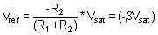
The output will remain –V_{sat} as long as v_{in} > V_{ref}.
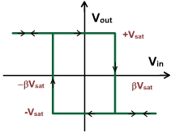 | 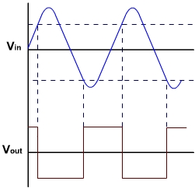
Fig. 3 | Fig. 4
If v_{in} < V_{ref} i.e. v_{in} becomes more negative than –V_{sat} then again output switches to +V_{sat} and so on. The transfer characteristic of Schmitt trigger circuit is shown in fig. 3. The output is also shown in fig. 4 for a sinusoidal wave. If the input is different than sine even then the output will be determined in a same way.
Positive feedback has an unusual effect on the circuit. It forces the reference voltage to have the same polarity as the output voltage, The reference. voltage is positive when the output voltage is high (+v_{sat}) and negative when the output is low (–v_{sat}).
In a Schmitt trigger, the voltages at which the output switches from +v_{sat} to –v_{sat} or vice versa are called upper trigger point (UTP) and lower trigger point (LTP). the difference between the two trip points is called hysteresis.
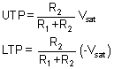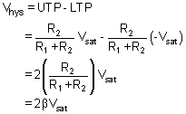

Filters:
A filter is a frequency selective circuit that, passes a specified band of frequencies and blocks or attenuates signals of frequencies outside this band. Filter may be classified on a number of ways.
- Analog or digital
- Passive or active
- Audio or radio frequency
Analog filters are designed to process only signals while digital filters process analog signals using digital technique. Depending on the type of elements used in their consideration, filters may be classified as passive or active.
Elements used in passive filters are resistors, capacitors and inductors. Active filters, on the other hand, employ transistors or OPAMPs, in addition to the resistor and capacitors. Depending upon the elements the frequency range is decided.
RC filters are used for audio or low frequency operation. LC filters are employed at RF or high frequencies.
The most commonly used filters are these:
- Low pass filters
- High pass filter
- Band pass filter
- Band reject filter.
- All pass filter
Fig. 1, shows the frequency response characteristics of the five types of filter. The ideal response is shown by dashed line. While the solid lines indicates the practical filter response.
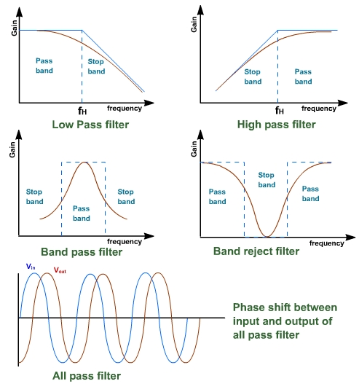
Fig. 1
A low pass filter has a constant gain from 0 Hz to a high cutoff frequency f_{H}. Therefore, the bandwidth is f_{H}. At f_{H} the gain is down by 3db. After that the gain decreases as frequency increases. The frequency range 0 to f_{H} Hz is called pass band and beyond f_{H} is called stop band.
Similarly, a high pass filter has a constant gain from very high frequency to a low cutoff frequency f_{L}. below f_{L} the gain decreases as frequency decreases. At f_{L} the gain is down by 3db. The frequency range f_{L} Hz to ∞ is called pass band and bleow f_{L} is called stop band.
First Order Low Pass Filter:
Fig. 2, shows a first order low pass Butter-worth filter that uses an RC network for filtering, opamp is used in non-inverting configuration, R₁ and R_{f} decides the gain of the filter.
According to voltage divider rule, the voltage at the non-inverting terminal is:
Fig. 2
Thus the low pass filter has a nearly constant gain A_{f} from 0 Hz to high cut off frequency f_{H}. At f_{H} the gain is 0.707 A_{f} and after f_{H} it decreases at a constant rate with an increases in frequency. f_{H} is called cutoff frequency because the gain of filter at this frequency is reduced by 3dB from 0Hz.
Filter Design:
A low pass filter can be designed using the following steps:
- Choose a value of high cutoff frequency f_{H}.
- Select a value of C less than or equal to 1 µF.
- Calculate the value of R using 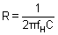.
- Finally, select values of R1 and RF to set the desired gain using 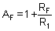.
Example - 1
Design a low pass filter at a cutoff frequency of 1 kH z with a pass band gain of 2.
Solution:
Given f_{H} = 1 kHz. Let C = 0.01 µF.
Therefore, R can be obtained as
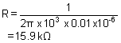
A 20 kΩ potentiometer can be used to set the resistance R.
Since the pass band gain is 2, R₁ and R_{F} must be equal. Let R₁ = R₂ = 10 kΩ.
First Order High Pass Butterworth filter:
Fig. 3, shows the circuit of first order high pass filter.This is formed by interchanging R and C in low pass filter.
The lower cut off frequency is f_{L}. This is the frequency at which the magnitude of the gain is 0.707 times its pass band value. All frequencies higher than f_{L} are pass band frequencies with the highest frequency determined by the closed loop bandwidth of the OPAMP.
The magnitude of the gain of the filter is | Fig. 3
If the two filters (high and low) band pass are connected in series it becomes wide band filter whose gain frequency response is shown in fig. 4.
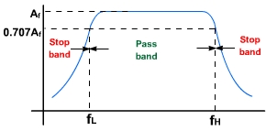
Fig. 4

